EDA 7943 Field Project 1:

Adult Literacy Tutor Initiative

Kristin Brittain

Florida Atlantic University

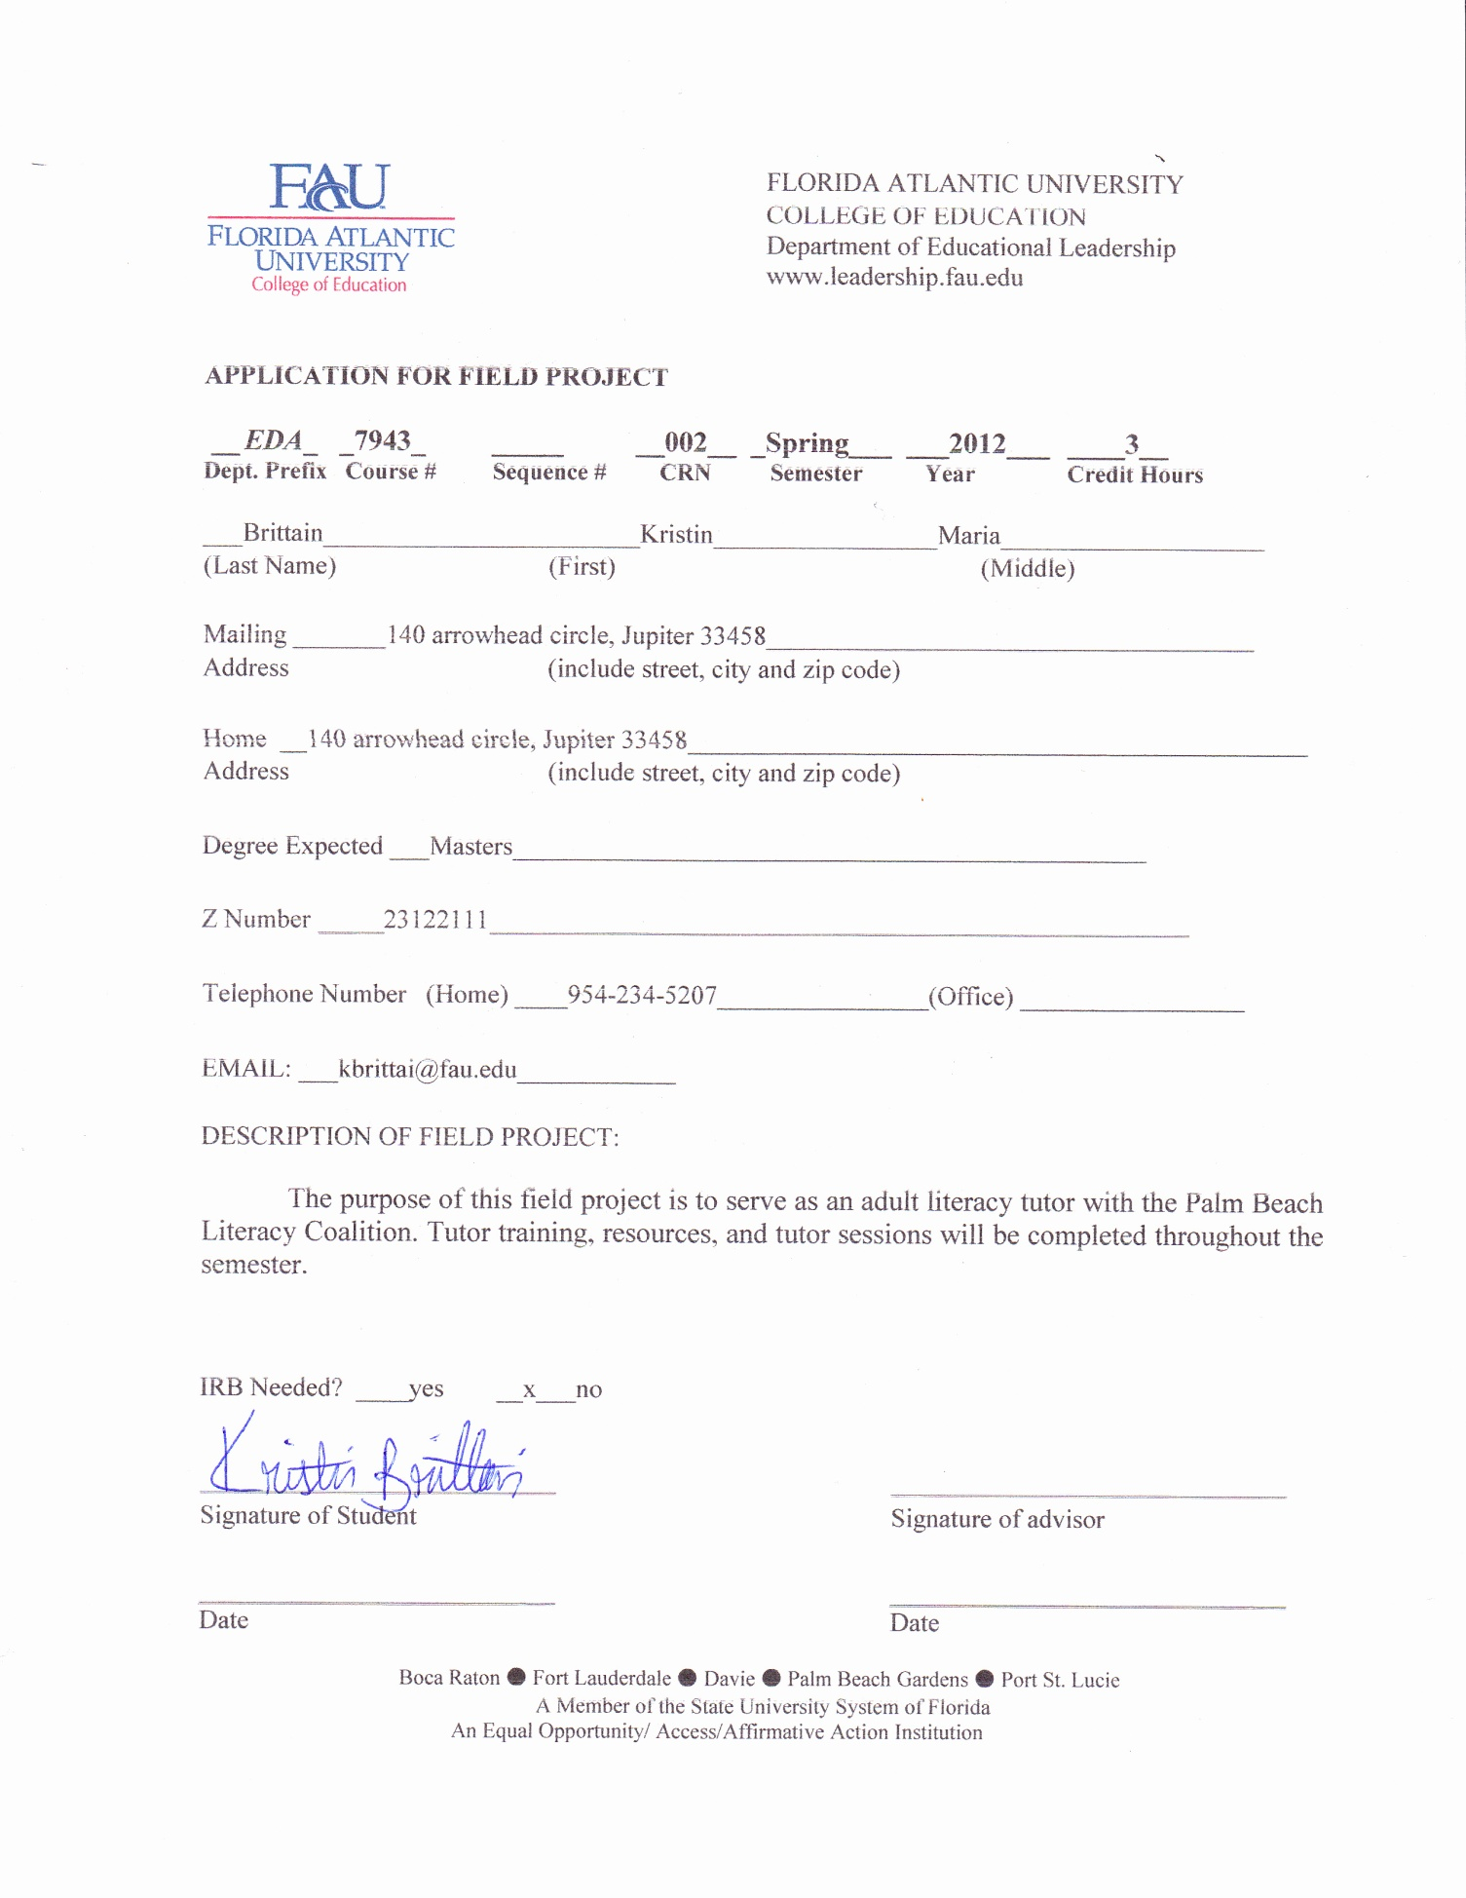

Learning Contract

Introduction

Education is the most useful tool an individual can be given. Literacy is a basic survival skill needed within society’s transformation from the industrial to the information age. According to Learning in Adulthood A Comprehensive Guide (2007), “the ultimate goal of education is to bring about behavior that will ensure survival of the human species, societies, and individuals” (Merriam, S.B., Caffarella, R.S. & Baumgartner, L.M., p. 280) and this goal is inclusive to everyone. Knowledge and information are key assets in the information age. “Educators, employers, and society at large are focusing attention on developing the skills needed to be productive and informed members of a fast-changing and highly technical society” (Merriam, S.B., Caffarella, R.S. & Baumgartner, L.M., p. 25). It is every human beings right to receive at least the minimal educational requirements to function in today’s civilization.

The National Council of Teachers of English, *Standards for the English Language Arts* (1996) states, “to fully participate in society and the workplace in 2020, citizens will need powerful literacy abilities that until now have been achieved by only a small percentage of the population.” Even as the world marches into the 21st century with science, technology, and medical advancements evolving beyond what anyone thought capable, so many individuals are being marginalized. According to The Literacy Company (2010), “more than 20 percent of adults read at or below a fifth-grade level- far below the level needed to earn a living wage” and “approximately 50 percent of the nation’s unemployed youth age 16-21 are functional illiterate, with virtually no prospects of obtaining good jobs.” The statistics are staggering and are only expected to rise.

Adult basic education is created for adults sixteen years of age and older to improve basic reading, writing, and mathematical skills. It is flexible, individually paced, and structured to meet the goals of individual learners. Adult basic education’s primary focus is on improvement of literacy skills in order for adults to successfully survive in today’s information age. This includes life strategy skills, attainment of a General Education Diploma (GED), resume and job application writing tips, and college readiness programs. The current extent of adult education in Florida encompasses many institutional, community, and self-regulated amorphous field of practices. There are many different programs offered state-wide: English for Speakers of Other Languages (ESOL), Adult Basic Education (ABE), Adult Secondary Education (ASE), Adult literacy initiatives (profit and not-for profit), and community education programs. ESOL, ABE, and ASE are programs created specifically for adults who are attempting to create a more educated society by providing basic writing, mathematical, and conversational knowledge and skills to successfully compete in today’s evolving technological world. Palm Beach Literacy Coalition, El Sol, and the Palm Beach Library’s adult education initiatives serves as an example of what adult basic education and ESOL programs that are available to just one county (West Palm Beach) in Florida.

The purpose of this field project is to serve as an adult literacy tutor with the Palm Beach Literacy Coalition. This organization has a specific program geared towards thousands of adults in the Palm Beach County who lack the necessary literacy skills. Persons for whom English is a second language are also recruited for English classes that serve the needs of many nationalities in the Palm Beach County. During the 2010-2011 year 158 volunteers were trained to be adult literacy tutors, 1,284 adult were connected to literacy programs, and 181 outreach sites were visited by the Palm Beach Literacy Coalition.

Objectives

The objective of this field project is to become a part of the initiative to help create a more informed and educated society. The most common goal amongst community based learning is a focus on social action and change for the betterment of the community, “educators who work in these programs believe that education and training can be a powerful tool in assisting learners to take control over their own lives” (Merriam, S.B., Caffarella, R.S. & Baumgartner, L.M., p. 32). This will be done by strictly focusing on the relevant topic of adult illiteracy. Currently, despite all of the efforts of fundraising and lobbying, the majority of literacy and community education programs are drastically underfunded and rely on the community for volunteers. During the tenure of this field project I will volunteer at the Palm Beach Literacy Coalition as an adult literacy tutor.

Objectives include:

* To complete tutor training provided by the Palm Beach Literacy Coalition
* To develop resources and instructional techniques
* To complete adult literacy tutoring sessions
* Reflect upon literature and tutoring sessions

Tentative Resource List

* Palm Beach Literacy Coalition
  + The Palm Beach Literacy Coalition’s mission is to improve the quality of life amongst the county of Palm Beach by improving literacy throughout the community. The organization provides programs ranging from adult and family literacy, workplace and community education, and issues on bullying. The coalition provides tutor training workshops and resources for volunteers.

<http://www.floridaliteracy.org/index.html>

* Florida Literacy Coalition
  + The Florida Literacy Coalition is the overarching organization that supports the entire state of Florida’s avocation and support of family and adult literacy initiatives. The organization supports over 300 adult education, literacy, and family literacy sites. The coalition is rich with resources for volunteers, educators, and literacy advocates. Materials, books, and information are available on the website and can also be ordered free of charge.

<http://www.literacypbc.org/>

Proposed Products

The proposed product is a six month commitment and will be completed in June 2012. For the sake of this Field Project volunteer training will be completed in December of 2011, a continuing resource matrix will be created and updated during my tenure as an adult literacy tutor, tutoring sessions will be conducted weekly, and a final reflective paper will be written.

Criteria for evaluation

The criteria for evaluation will be based upon whether tutor training and a valid resource matrix is completed. A final reflective paper will also serve as a method for evaluation.

Tutor Training Completion

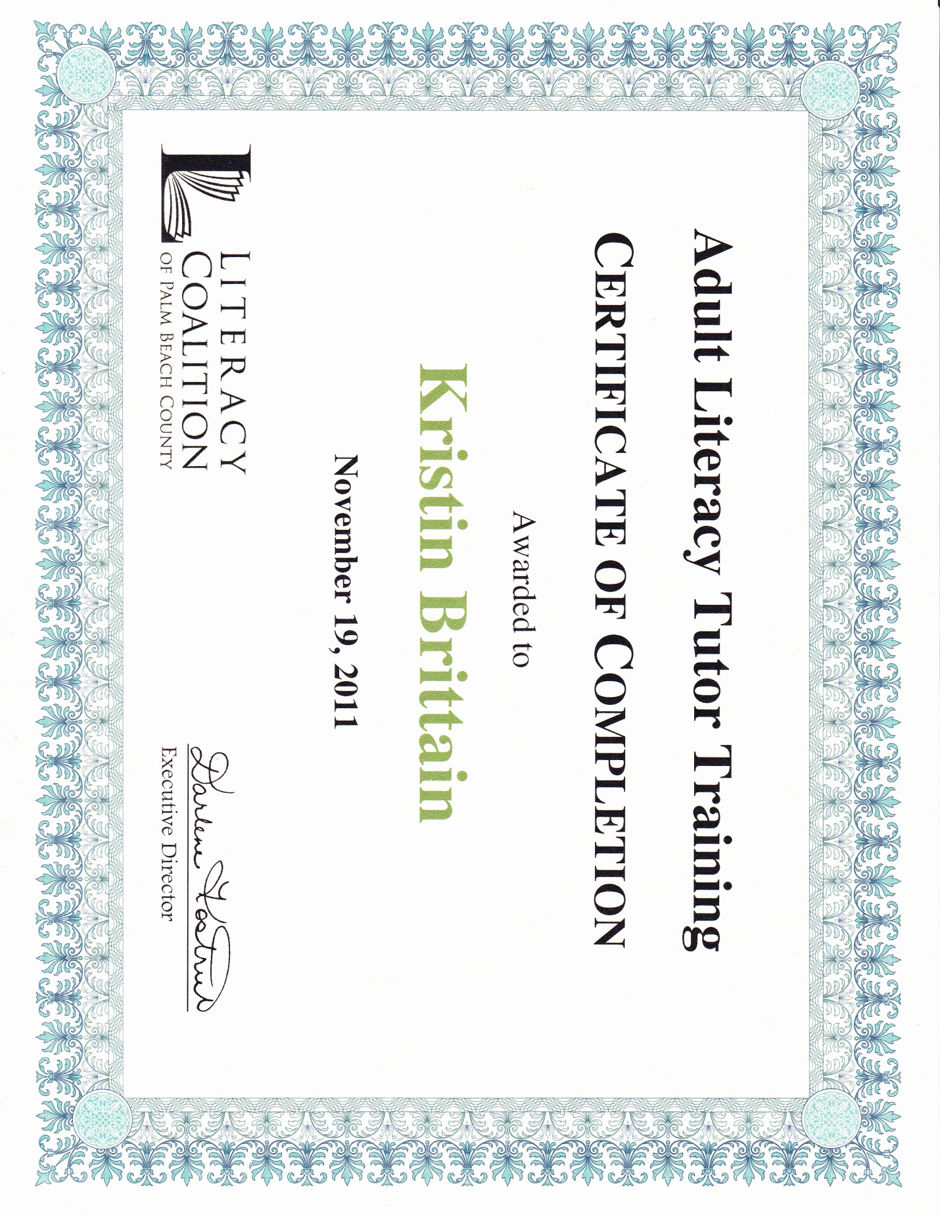On November 19, 2011, I completed the tutor training program implemented by the Palm Beach Literacy Coalition. The session was informative and assessable. It provided the group with the information and resources needed to become an adult literacy tutor. There were about twenty people whom attended the session. The ages of the tutors ranged from early twenties to late seventy’s. Materials were provided for the tutors to use with their adult learners, workbooks, handouts, and pamphlets were supplied.

Adult Literacy Resource Matrix

|  |  |  |
| --- | --- | --- |
| Resource | Background | Method of Use/ Application |
| LITSTART: Strategies for Adult Literacy and ESL Tutors | Third edition of LITSTART by the Michigan Literacy, Inc. The book provides adult literacy tutors with strategies, resources, and instructional techniques to improve their students’ proficiency levels in reading, writing, and speaking English. | The book presents specific strategies and instructions for tutors to utilize with their adult learners.   * Planning tutoring sessions * Selecting a reading strategy * Phonics teaching tips * Communicating with student |
| Preferred Learning Style   * <http://www.acceleratedlearning.com/> | Knowing a learner’s preferred learning style (way of learning that best suits the student) will give the tutor better foresight into how to better help the individual learn. | Help the student finish the preferred learning style assessment and create a learner’s profile. |
| Reading Rockets Teaching Kids to Read and Helping Those Who Struggle   * <http://www.readingrockets.org/article/263/> | This website provides articles on different instructional techniques for individuals struggling with literacy at all levels and ages. | The website supplies many useful articles, such as:   * “What Is Differentiated Instruction?”by: Carol Ann Tomlinson * “Second Language Acquisition” by: American Speech-Language-Hearing Association |
| Expressing yourself in English   * <http://www.expressingyourselfinenglish.com/> | Online resource for English language learners. This site provides instructional techniques for the tutor as well as the student. A three-part strategy is provided to help improve conversational English skills. | The techniques provided on the site are useful in tutoring ESL adults.   * Most common used English words * Using correct tense |
| Florida LINCS   * <http://www.floridaliteracy.org/teacher/game_ideas.asp> | Tutor tips and games are provided in the website. | * Game ideas |
| Comprehensive Reading and Strategies Help   * <http://www.floridatechnet.org/inservice/abe/reading/> | This website provides an online training course full of information and resources to provide better instructional opportunities and activities to enhance reading skills for adult learners. | Gives an overview of the adult learner and specific strategies to aid their learning. |
| Literacy Connection Promoting Literacy and a Love of Reading   * <http://www.literacyconnections.com/> | This website boasts a vast amount of information on adult literacy, ESL, reading and tutoring resources. | * Tips for reading tutors: <http://literacyconnections.com/AdviceForReadingTutors.php> * Adult literacy and educational resources |
| Reading Skills for Today’s Adults   * <http://resources.marshalladulteducation.org/reading_skills_home.htm> | This website provides specific stories geared towards adult learners solely. | The website provides:   * Steps involved in the “Reading Skills” program * Adult related and content specific stories |
| Sherow Tutor Flipbook   * <http://www.floridaliteracy.org/Flipbook.pdf> | This is a Flipbook/instructional book made available through the Florida Literacy Coalition. It is divided into five sections and includes instructional material and techniques, learning/teaching strategies, and other helpful tips. | The book is divided into five section; the tips are very helpful. The specific sections used were:   * Reading instruction * Teaching/ learning strategies |
| The Internet Picture Dictionary   * <http://www.pdictionary.com/> | This website provides an online dictionary in which a picture is present to represent each word. | This is a great resource for ESL learners. |
| Palm Beach Literacy Coalition   * <http://www.literacypbc.org/> | The Palm Beach Literacy Coalition’s mission is to improve the quality of life amongst the county of Palm Beach by improving literacy throughout the community. The organization provides programs ranging from adult and family literacy, workplace and community education, and issues on bullying. The coalition provides tutor training workshops and resources for volunteers. | * Provides resources, site locations, and other programs available |
| Florida Literacy Coalition   * <http://www.literacypbc.org/> | The Florida Literacy Coalition is the overarching organization that supports the entire state of Florida’s avocation and support of family and adult literacy initiatives. The organization supports over 300 adult education, literacy, and family literacy sites. | The coalition is rich with resources for volunteers, educators, and literacy advocates. Materials, books, and information are available on the website and can also be ordered free of charge. |

Reflection

The tutoring process and techniques

During the Palm Beach Literacy Coalition’s tutor training, the group was taught the three ingredients of successful tutors: patience, open heart, and desire to help. The most important attribute needed to become an adult literacy tutor is the desire to help and the desire to impact everyone in the student’s life. “I need to do this for my family,” “learning to read will help me get a better job so I can support my daughter,” “I can’t tell my kids I can’t read” are common responses from many adult learners. Learning new literacy skills will not only affect the learner’s quality of life, but it will directly affect the families these students support. Literacy skills are needed to function properly within society. One cannot even work the most minimal of jobs unless the individual can fill out a job application. The ability to provide an adult with the necessary tools to gain an occupation is a powerful instrument. The tutor training provided insight to the adult student lives, and as to what operating as a functional illiterate is like. Their world is grim without the literacy skills needed. However, people are willing to help.

While completing this field project, during my tenure as an adult literacy tutor, I not only learned about adult literacy, but I also gained a lot of insight regarding instructional techniques. The first barrier to adult literacy is the individuals who lack the literacy skills to begin with. The majority of the adult learners initially have concerns seeking help and often times are embarrassed. Individuals lacking basic reading skills seem to be more reluctant to take advantage of the services offered than English Language Learners (ESL). Secondly, the adult learners must trust the instructor to provide them with the proper help and educational support. Due to these barriers the first ingredient to becoming a successful tutor is having an open heart. A lot of these adult learners come from a hard background, with various experiences. One ESL adult learner spoke often regarding his escape from his former home in Cuba in order to create a better life for his family. He discussed the many obstacles he faced on his journey over here, as well as his continual survival for him and his family in America.

In order for optimal learning to occur, creating a comfortable and trusting environment between the tutor and student is the most important step to establish. There are several techniques that can be done to launch this connection. The tutor can try to make the student comfortable, engage in conversation, recognize that the students are adults, and treat them as such. Also, as a tutor, stand back from the student, let them lead the lesson; sit by their side and not across from the student so you’re not “instructing them authoritatively.” I found that I was more successful with the adult learners whom I had an established relationship with. During the sessions with the students I was more comfortable and familiar with the learner felt at ease, and made more attempts to learn new knowledge instead of being preoccupied with other concerns.

The second ingredient, patience, is imperative to keep in mind during tutoring sessions. Every individual learns differently and at their own pace, and patience is essential to the tutor/student relationship. Also, it is important to remember, some days are better than others and knowledge is a continual journey. Improvements should be recognized no matter the size. To me, there was nothing better than to see one of my adult learners “get it.” Helping these individuals gain the knowledge to fully operate in today’s world is also providing them with the tools for happiness and success. Teaching adults’ literacy skills can be a frustrating process, so when the student’s realized that yes, they are learning something, the moment was priceless.

To ease the level of frustration amongst both student and tutor, a learning profile should be created on each adult learner. The tutor must take the time in the beginning of the tutoring journey to find out the specific learning style the student utilizes. Also, it is imperative to know the specific learning objectives the student wishes to complete, and plan accordingly. Two of the techniques taught to adult literacy tutors is repetition and “read alouds.” These two reading strategies allow the student to become familiar with the text and the way it sounds when read aloud.

The Palm Beach Literacy Coalition’s training emphasized constant repetition, practice, and reading aloud as the most effective reading techniques. This is a contradiction from the over emphasis on phonetics touted by other literacy organizations. The claim made by the Palm Beach Literacy Coalition is that not every letter can by sounded out in every word in the English language, and this phenomenon confuses many learner’s.

Also, providing prior knowledge about the reading subject to the learner is essential as well. This is important to bear in mind when practicing reading skills with adults, because reading is a process of making meaning and comprehension from sentences. This gives the selected reading context for the learner, and it will evidently make more sense to them. An example from a tutoring session is reading a poem about Christopher Columbus. In order for the learner to understand the poem better, and in turn read it more properly and gain new knowledge regarding the subject, is before actually reading the poem I asked the learner, “what do you know about Christopher Columbus?” and then began discussing the required reading’s subject and the student’s prior knowledge.

Reading along with students, modeled reading, coached reading, and repeated reading are all reading literacy techniques that was taught during the tutor training sessions. I found reading along and modeled reading to be most effective with adult learners. Adults can be reluctant to step forward and admit they need help in order to learn, but when faced with the possibility of being unable to help their children with their vocabulary words, or comprehension assignments (this was a common theme amongst adults wanting to become more proficient at all educational levels, wanting to have the ability to help their children), turning to a literacy tutor became a lot easier.

Experience

A vast majority of community education programs rely on volunteers. The desire to help is fundamental to the tutoring process. The aim of these programs is to assist individuals reach their potential and thus create a more intelligent and well-rounded community. Many organizations providing adult and family literacy programs were in dire need of volunteers. I felt overwhelmed to help. This process taught me a lot. Not only did I improve on my tutoring techniques, but holistically I felt like a more open and inclusive human being. I enjoyed my experience as a literacy tutor, and it is something I am passionate about. This was a way in which I could provide my personal attributes to help others. There is no greater tool than the ability to read and write, and I found that the majority of my students were eager to learn. An important “AHA” moment during this field project happened while listening to some of the adult learners’ personal life histories. I heard tales of fleeing one’s homeland in order to provide a better life for one’s children, others dropping out of school as a young child to help support their family financially, and individuals who simply did not see the need for education as a younger child; the stories and reasoning’s are endless. I can’t think of anything that has been more rewarding, or has given me a greater sense of productivity.

The semester was long, and profound. I learned how to open myself up as a person and instructor. I heard a lot of heart breaking stories about individuals who did not get the proper educational opportunities, and many adults who were embarrassed by their inability to read and write. I saw a lot of successes, as well as others who did not return for their next tutoring session. I learned that when one is ready to work for the gift of education; they are ready to take on life. As an adult literacy tutor it is interesting to see the invisible restrictions that are crossed between student and tutor, adults transforming from illiterate to literate, which in turn remove boundaries from students that were never crossed before. It is inspiring and satisfying to see a student succeed and graduate to the next stage of life. It is great to see people volunteering their abilities to create a better and more functioning society.

Activity Log

|  |  |
| --- | --- |
| Time Spent | **Activity** |
| November 19, 9:00- 5:00:  8 hours | Palm Beach Literacy Coalition’s tutor training |
| December:  5 hours | Development of resources |
| January 7, 12:00-2:00:  2 hours | Tutor Session |
| January 10, 6:00-8:00  2 hours | Tutor Session |
| January 14, 12:00-2:00  2 hours | Development of student profiles and assessments |
| January 17, 6:00-800:  2 hours | Tutor Session |
| January 21, 12:00-2:00  2 hours | Volunteer at Literacy Coalition |
| January 24, 6:00-8:00:  2 hours | Tutor Session |
| January 31, 6:00-8:00  2 hours | Tutor Session |
| February 4, 1:00-2:00  1 hour | Update student profiles |
| February 7, 6:00-8:00  2 hours | Tutor Session |
| February 21, 6:00-8:00  2 hours | Tutor Session |
| February 25, 11:00- 3:00  4 hours | Palm Beach Library adult literacy resources |
| February 28, 6:00-8:00  2 hours | Tutor Session |
| March 3, 11:00-2:00  3 hours | Update resources, student profiles, and prepare for future sessions |
| March 6, 6:00-8:00  2 hours | Tutor Session |
| March 13, 6:00-8:00  2 hours | Tutor Session |
| April 14, 12:00-4:00  4 hours | Palm Beach Literacy Coalition |
| April 17, 6:00-8:00  2 hours | Tutor Session |
| April 24, 6:00-8:00  2 hours | Tutor Session |
| April 25, 12:00-1:00  1 hour | Prepare for future sessions |

References

National Council of Teachers of English. (1996). *Standards for the English Language Arts*.

United States of America: International Reading Association.

Merriam, S.B., Caffarella, R.S. & Baumgartner, L.M. (2007). *Learning in Adulthood: A comprehensive guide*. San Francisco, CA: Jossey-Bass.

The Literacy Company. (2010). *Reading, Literacy & Education Statistics* [Data file]. Retrieved from http://www.readfaster.com/education_stats.asp#literacystatistics